Jennifer DeVore

1 April 2020

CIS 435

**Unit 5 Graded Exercise 1: Working with Cursors**

1. **Write a script to declare and use a cursor for the following SELECT statement. Use a WHILE loop to fetch each row in the result set. Omit the INTO clause to fetch directly to the Results tab.  
   SELECT VendorName, AVG(InvoiceTotal) AS InvoiceAvg FROM Vendors JOIN Invoices  
   ON Vendors.VendorID = Invoices.VendorID GROUP BY VendorName;**

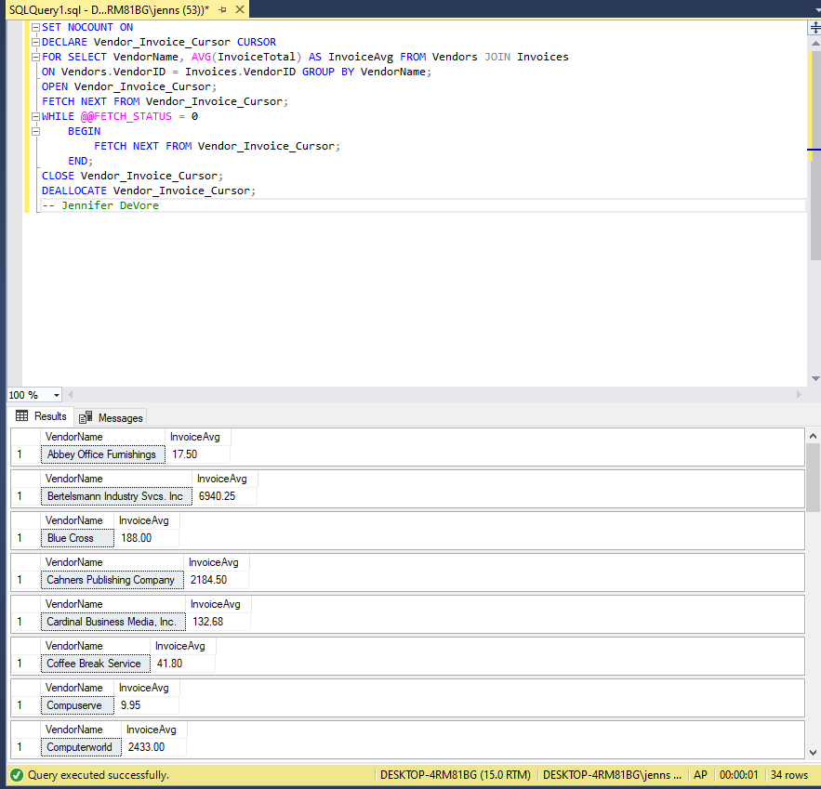

1. **Modify the solution to exercise 1 to fetch each row into a set of local variables. Use the PRINT statement to return each row in the format “Name, $0.00” to the Messages tab.**

